**Test Case** **0048**

**System:** VirtuCardsClient & VirtucardsHost

**Description:** Tests that a player can fold their hand

**Severity:** 3

**Instructions**

**Test 1**

1. Start VirtuCardsHost application
2. Click the button labeled “Sign In”
3. Enter “virtucards01@gmail.com” into the text input labeled “Enter email…”
4. Enter “Testing1” into the text input labeled “Enter password…”
5. Press the button labeled “Login”
6. A window should appear saying “Login Success”
7. Press the OK button that appears on that window
8. Start the VirtuCardsClient application
9. Press the button labeled “Play Anonymously”
10. Repeat steps 8-9 on two other VirtuCardsClient applications
11. Select the game “Poker” from the dropdown on the host
12. Press the Create Game button
13. On all the VirtuCardClient applications enter the 6-character room code found on the host’s screen into the field labeled “Enter Code…”
14. Press the Join Game button on each
15. On the host side, press the Start Game button
16. On the client whose turn it is, press the “Fold” button

**Expected Result:** The player should have their cards removed from their hand, and the turn should pass to the next player

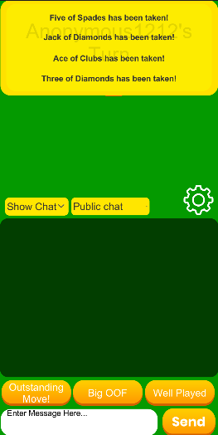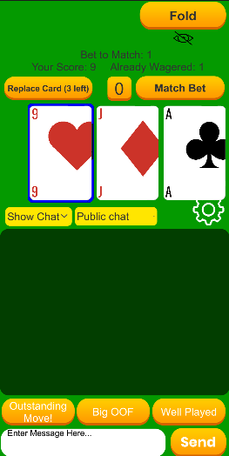

**First Client Before and After Pressing Fold**

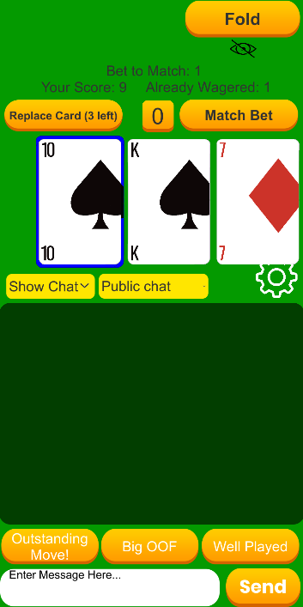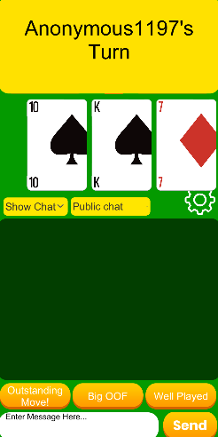

**Second Client Before and After Fold was Pressed on First Client**

**Test 2**

1. Start VirtuCardsHost application
2. Click the button labeled “Sign In”
3. Enter “virtucards01@gmail.com” into the text input labeled “Enter email…”
4. Enter “Testing1” into the text input labeled “Enter password…”
5. Press the button labeled “Login”
6. A window should appear saying “Login Success”
7. Press the OK button that appears on that window
8. Start the VirtuCardsClient application
9. Press the button labeled “Play Anonymously”
10. Repeat steps 8-9 on two other VirtuCardsClient applications
11. Select the game “Poker” from the dropdown on the host
12. Press the Create Game button
13. On all the VirtuCardClient applications enter the 6-character room code found on the host’s screen into the field labeled “Enter Code…”
14. Press the Join Game button on each
15. On the host side, press the Start Game button
16. On the client whose turn it is, press the “Fold” button
17. The turn should pass to the next client. On the client whose turn it is, press the “Match Bet” button
18. Repeat step 15

**Expected Result:** The turn should advance to the second player who hit the “Match Bet” button. It should not go to the client who pressed the “Fold” button

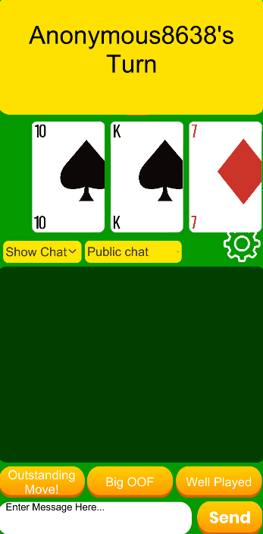

**Before and After of First Client who hit “Match Bet”**

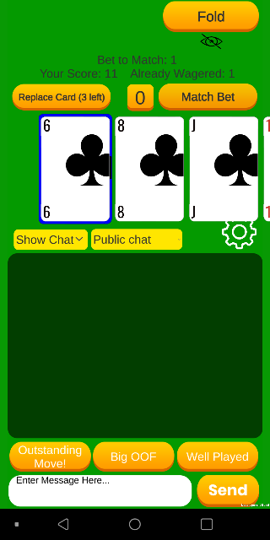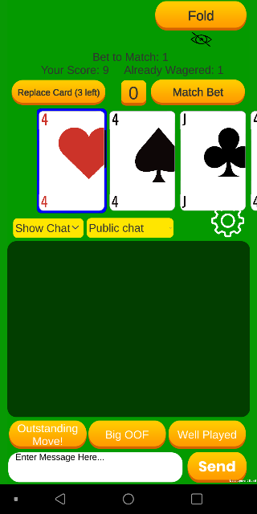

**Before and After of Second Client who hit “Match Bet”**

**Test 3**

1. Start VirtuCardsHost application
2. Click the button labeled “Sign In”
3. Enter “virtucards01@gmail.com” into the text input labeled “Enter email…”
4. Enter “Testing1” into the text input labeled “Enter password…”
5. Press the button labeled “Login”
6. A window should appear saying “Login Success”
7. Press the OK button that appears on that window
8. Start the VirtuCardsClient application
9. Press the button labeled “Play Anonymously”
10. Repeat steps 8-9 on another VirtuCardsClient application
11. Select the game “Poker” from the dropdown on the host
12. Press the Create Game button
13. On all the VirtuCardClient applications enter the 6-character room code found on the host’s screen into the field labeled “Enter Code…”
14. Press the Join Game button on each
15. On the host side, press the Start Game button
16. On the client whose turn it is, press the “Fold” button

**Expected Result:** The round should end with the client who did not press fold being declared the winner. On the start of the next round, that player should be dealt back in.

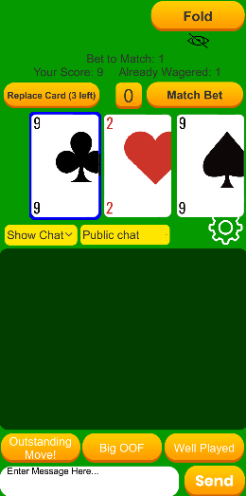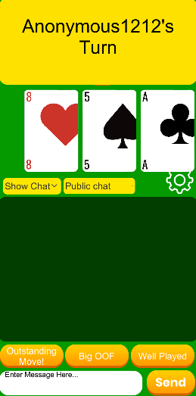

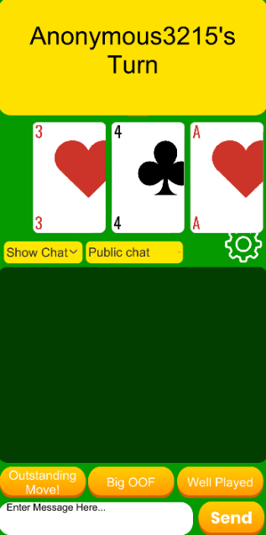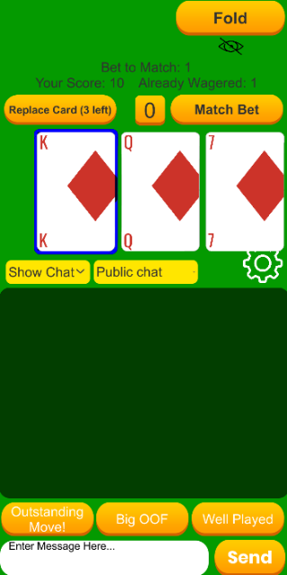 **Before and After of First Client who hit “Fold”**

**Second Client Before and After the First Client hit “Fold”**

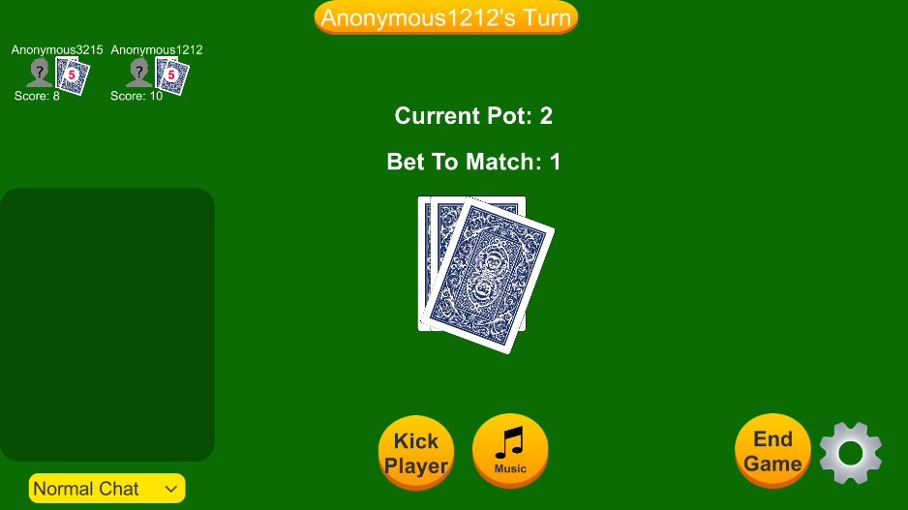

**The Host after the First**

**Client Pressed “Fold”**

**Showing that the**

**Second Client won the**

**Round.**

**Test 4**

1. Start VirtuCardsHost application
2. Click the button labeled “Sign In”
3. Enter “virtucards01@gmail.com” into the text input labeled “Enter email…”
4. Enter “Testing1” into the text input labeled “Enter password…”
5. Press the button labeled “Login”
6. A window should appear saying “Login Success”
7. Press the OK button that appears on that window
8. Start the VirtuCardsClient application
9. Press the button labeled “Play Anonymously”
10. Repeat steps 8-9 on another VirtuCardsClient application
11. Select the game “Poker” from the dropdown on the host
12. Press the Create Game button
13. On all the VirtuCardClient applications enter the 6-character room code found on the host’s screen into the field labeled “Enter Code…”
14. Press the Join Game button on each
15. On the host side, press the Start Game button
16. On the client whose turn it is, enter 5 into the input to the left of the button labeled “Match Bet”. Then press that button.
17. On the second client, press the button labeled “Match Bet”
18. Back on the first client, press the button labeled “Fold”

**Expected Result:** The round should end, and the second client should be declared as the winner. The first client should only have 3 score left, but the second client should have 15 score.

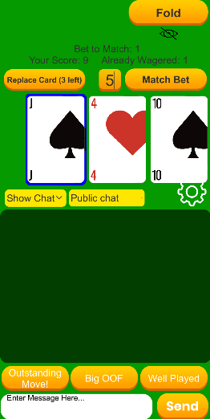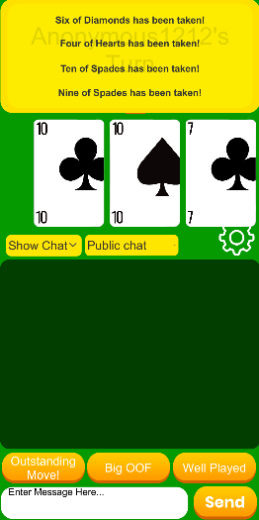

 **Before and After of First Client who hit “Fold”**

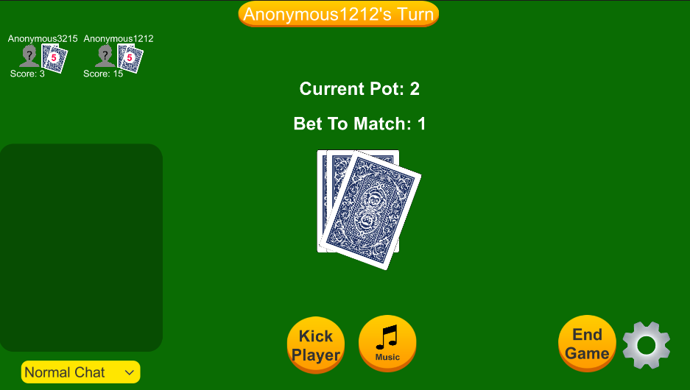 **Second Client Before and After the First Client hit “Fold”**

**Host Showing First Client with 3 score and the Second Client with 15 score**